**Week 5**

**Q-1 Write a Java program to insert 10, 20, 30 ....in an array and display them.**

import java.util.Scanner;

public class Week_5_Q1 {

    public static void main(String[] args) {

        int n;

        Scanner sc=new Scanner(System.in);

        System.out.print("Enter no. of elements stored in array:");

        n=sc.nextInt();

        int b[]=new int[n];

        for(int i=0;i<n;i++)

        {

            System.out.print("Enter element-"+(i+1)+":");

            b[i]=sc.nextInt();

        }

        System.out.println("Elements in array:");

       for(int element:b)

           System.out.println(element);

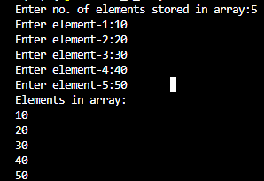    }

}

**Q-2 Write a Java program to calculate the sum of all the array elements.**

import java.util.Scanner;

public class Week_5_Q2 {

    public static void main(String[] args) {

        int n,sum=0;

        Scanner sc=new Scanner(System.in);

        System.out.print("Enter no. of elements stored in array:");

        n=sc.nextInt();

        int b[]=new int[n];

        for(int i=0;i<n;i++)

        {

            System.out.print("Enter element-"+(i+1)+":");

            b[i]=sc.nextInt();

        }

        for(int i=0;i<n;i++)

        {

            sum+=b[i];

        }

        System.out.println("Sum of array elements:"+sum);

    }

}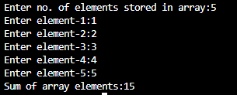

**Q-3 Write a java program to print the following pattern.**

**1**

**12**

**123**

**1234**

**12345**

import java.util.Scanner;

public class Week_5_Q3 {

    public static void main(String[] args) {

        Scanner sc=new Scanner(System.in);

        int n;

        System.out.print("Enter no. of rows:");

        n=sc.nextInt();

        int i,j;

        for(i=1;i<=n;i++)

        {

            for(j=n;j>i;j--)

            {

                System.out.print(" ");

            }

            for(j=1;j<=i;j++)

            {

                System.out.print(j);

            }

            System.out.print("\n");

        }

    }

}

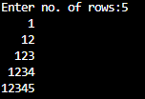

**Q-4 Write a java program to find the sum of following series where n is input by the user. 1+1/2+1/3+1/4+...............+1/n**

import java.util.Scanner;

public class Week_5_Q4 {

    public static void main(String[] args) {

        Scanner sc=new Scanner(System.in);

        int n;

        double sum=0;

        System.out.print("Enter n=");

        n=sc.nextInt();

        for(double i=1;i<=n;i++)

        {

            sum=sum+(1/i);

        }

        System.out.println("Sum of series:"+sum);

    }

}



**Q-5 Write a Java program and compute the sum of the digits of an integer.**

import java.util.Scanner;

public class Week_5_Q5 {

public static void main(String[] args) {

int n,sum=0,dig;

Scanner sc=new Scanner(System.in);

System.out.print("Enter integer:");

n=sc.nextInt();

while(n>0)

{

dig=n%10;

sum+=dig;

n=n/10;

}

System.out.println("Sum of digits="+sum);

}

}



**Q-6 Write a Java program to calculate the factorial of a number.**

import java.util.Scanner;

public class Week_5_Q6 {

    public static void main(String[] args) {

        Scanner sc=new Scanner(System.in); int n,fact=1;

        System.out.print("Enter no.:");

        n=sc.nextInt();

        for(int i=1;i<=n;i++)

        {

            fact=fact*i;

        }

        System.out.println("Factorial="+fact);

    }

}

